Sample Questions on NOSQL, OODBMS, DW

1.

|  |  |
| --- | --- |
| 1. Design a star schema for a data warehouse for income tax and income analytics of Bangladesh. 2. Perform rollup operations on your developed schema for the dimensional table time (date, day, month, year) and explain. 3. Perform cube operations on your developed schema for the dimensional table time (date, day, month, year) and explain. |  |
| 1. How will you use the star schema for decision support of National tax analysis? |  |

2. The ERD given as follows:

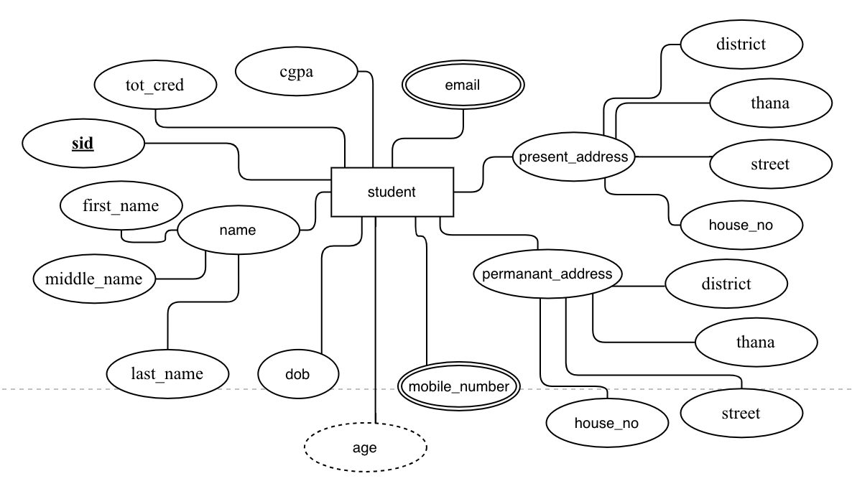

Implement name, mobile number in

1. Relational model.
2. ORDBMS
3. NoSQL